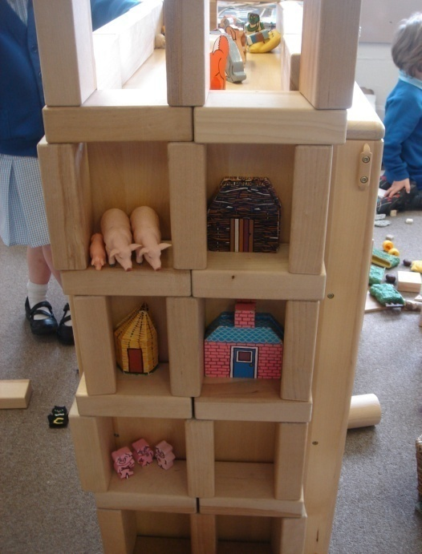
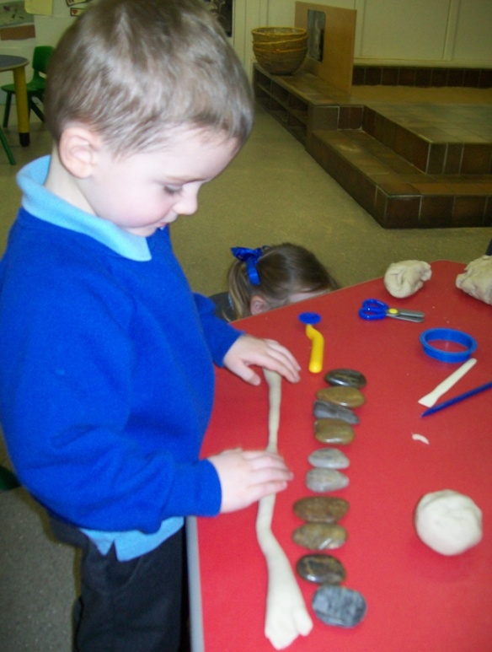
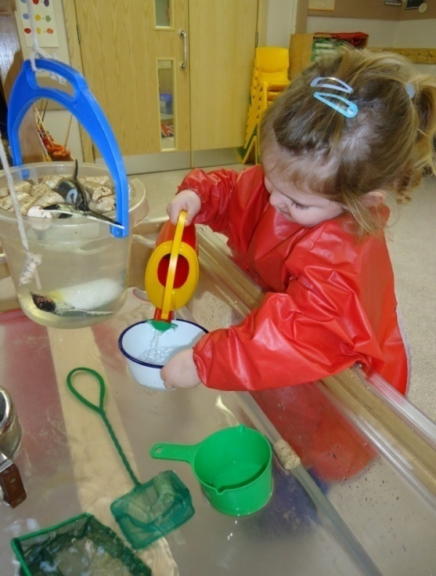
Mathematics learning in Nursery
There are many ways in which you can help your child with mathematics at home. Adults use lots of mathematics at home, in everyday activities such as cooking, shopping and DIY. We use a range of maths while spending money, measuring, calculating, and son. You can talk with your child about things like which coin to use for to pay for an ice pop, how many oranges you need putting in the basket, and whether or not they are taller or shorter than their cousins.

On the back of this leaflet you will find a list of some of the things your child will be learning about number. In Nursery the focus is on developing number language, reciting numbers in the correct order, accurate counting, developing the language of quantities, knowing that numerals represent how many objects are in a group and using marks and fingers to represent their ideas about numbers. But maths also includes grouping and sorting objects, simple shapes and patterns, developing the language of measures, capacity, and the concept of time. Your child will learn about all of these.
Ways to help your child with maths
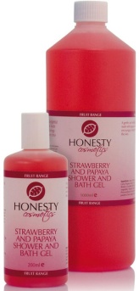
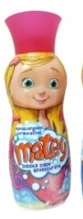

- Can you pick 3 toys for the bath?

- How many little cups of water will fill the jug?

- Good for developing number, capacity and size
- Good for developing number, size and problem solving
Maths in the bathroom
You can use bath time to develop mathematical skills.

- Choose three bottles. Can you put them in a row from smallest to biggest?

- Which bottle do you think will be the heaviest/lightest?

- Good for developing number, size and problem solving
Can you pass me three small carrots please?
Can you find two bowls the same size?
Can you pair all of the stripy socks?

Maths in the kitchen
You can use everyday life in the kitchen to develop mathematical skills.
How many plates will we need for dinner?
Put a biscuit on each plate. How many will you need?

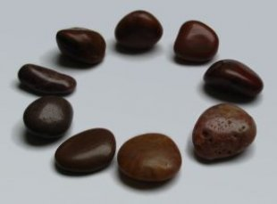
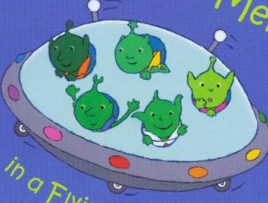
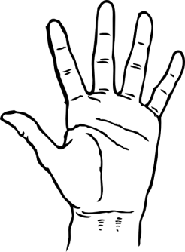
Pebbles and acorns
- How many can you hold in one hand?
- How many can you hold with two hands?

- Can you choose three of the smallest acorns? Now find two of the biggest pebbles. How many do you have altogether?

- Use a dice with dots if your child does not yet recognise numerals. Take turns to roll the die and collect that number of acorns. The first to fill their yoghurt pot wins.

- Make a small circle using acorns and a big circle using pebbles.

Number rhymes
Encourage your child to join in with number rhymes. You can adapt the ones you know by using different numbers or different things.

Five little men in a flying saucer
((hold five fingers up, after each verse is sung, model that you put a finger down as one of the men fly off)

Five little men in a flying saucer
flew around the world one day. They looked left and right and didn’t like the sight, so one man flew away, whoosh.

Four little men in a flying saucer
flew around the world one day. They looked left and right and didn’t like the sight, so one man flew away, whoosh.

And so on . . .

Rhymes and games

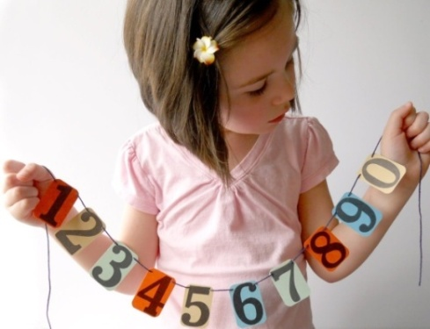
In Nursery your child will be learning to:
- Recite number rhymes such a ‘Baa Baa Black Sheep’, ‘Five Little Men in a Flying Saucer’, etc.

- Sort and group objects by, e.g. putting all the teddies together or cars and animals in separate piles.

- Select a small number of objects from a group, e.g. “please pass me one pencil”, “please pass me two of those biscuits”.

- Recite numbers by saying one, two, three, four . . . up to 10.

- Count up to 5 objects by saying one number name for each object.

- Begin to make comparisons between quantities.

- Create and experiment with symbols and marks, representing their ideas of number.

- Use words to compare things such as more, less, bigger, smaller, heavier, lighter.

- Know that a group of things change when something is added or taken away.

- Know that numbers identify how many objects are in a set.

- Match numerals and quantities.

